Lab 0 – Bootstrap

Task 1)

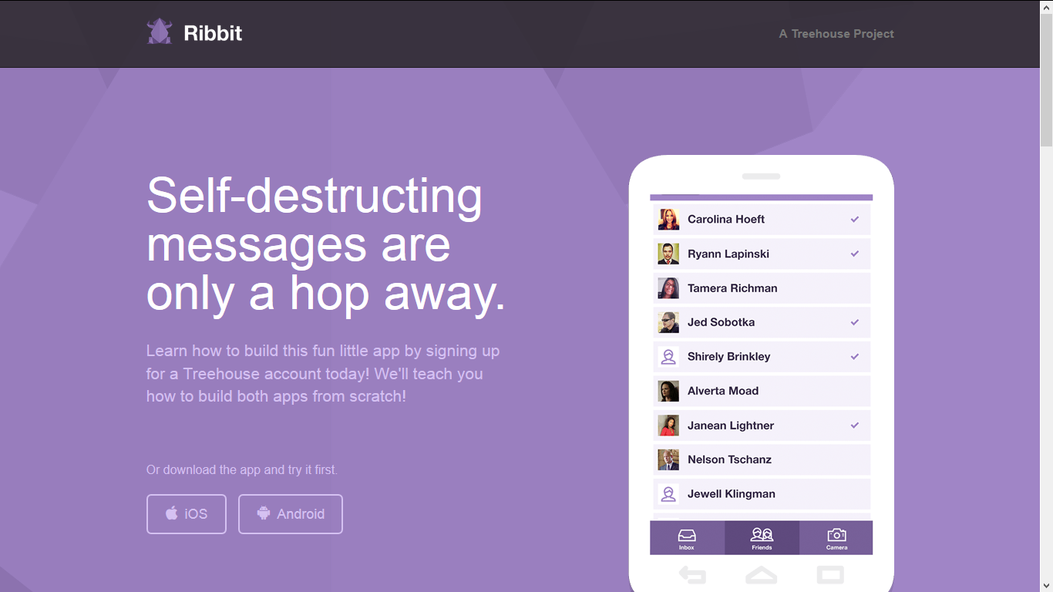

Create the following site! See the site assets in Ribbit Folder.

Task 2)

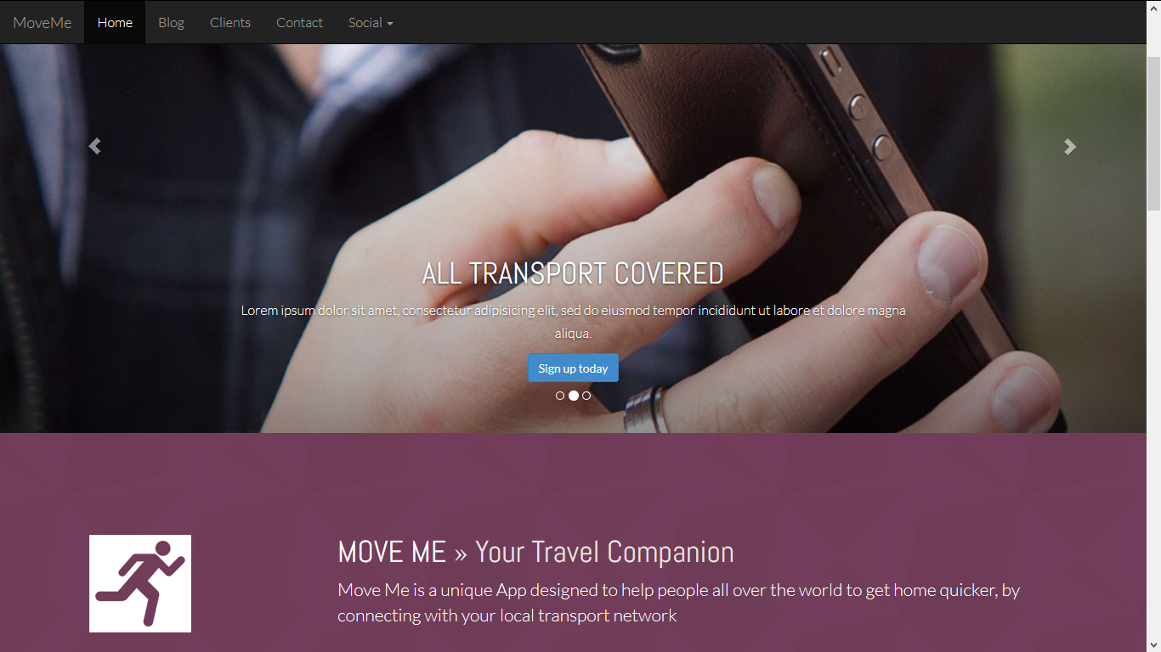

Please see all the files in Site folder – You are to replicate that site!

Task 2)